Tru-Cool Bracket Installation Kit
***Please view the following document before starting.***
Each kit consists of the following Item’s to install a Tru-cool 40K cooler on the 99-07 classic style GMT800 platform;
1 upper bracket
1 lower bracket
1 brass compression coupler fitting
2 cooler fittings
4 Bolts along with 4 matching threaded U- clips

Installation is shown for vehicles with existing external factory coolers. If you do not have the external factory cooler you will need to plumb the cooler differently by tapping into the transmission return line using the supplied hardware and tubing from the Tru-Cool cooler kit.
To install the brackets you will need to start by opening the hood and removing the plastic clips holding the cover directly above the grill. This can be done by prying the head of the clips straight up with a clip removal tool or equivalent tool such as a flat blade screw driver. There should be 7 of these clips on the 99-07 Classic trucks and SUV’s.
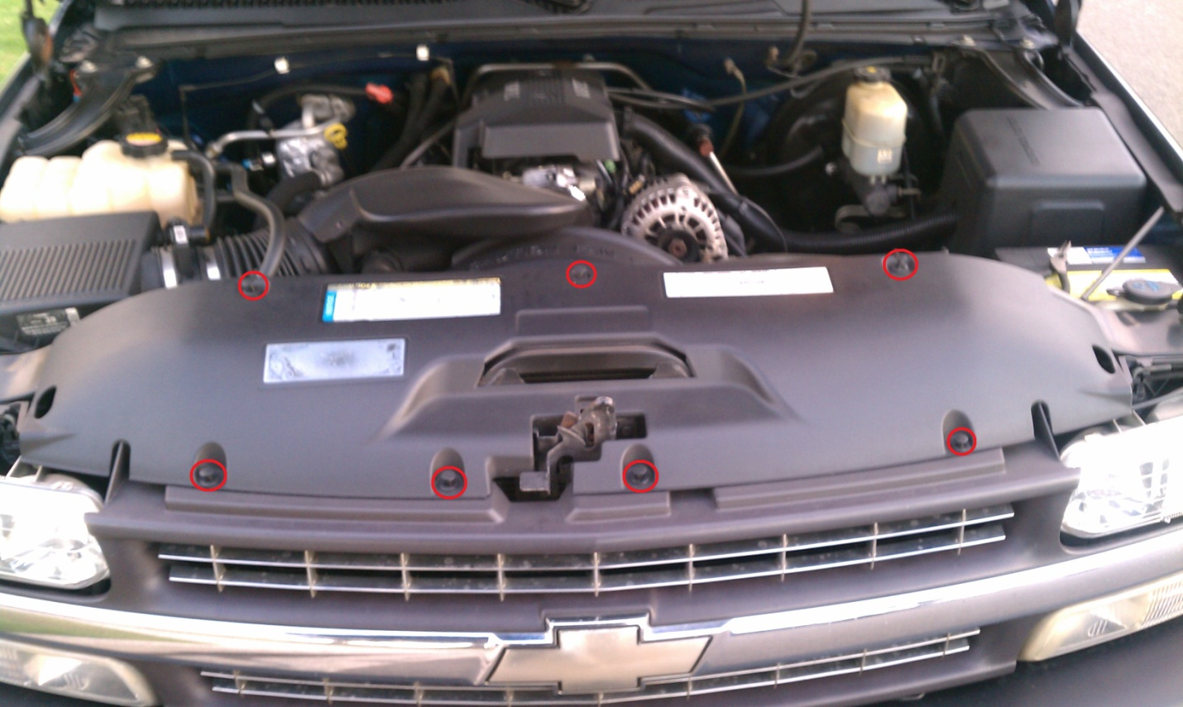
Once you remove the clips and the cover, you will need to remove the grill. The process is slightly different depending on the front end style you have.

For the 99-02 style front end there are 4 Plastic clips near the inside of the lights and one bolt directly in the center next to the Hood latch. These locations are indicated by the red arrows in the picture below. The 4 Plastic clips are Quarter turn fasteners that can be turned counter clock wise with a #2Philips screwdriver. The center bolt requires a socket to remove. The very outer ends are held in place by a metal clip. Carefully pull away from the body.
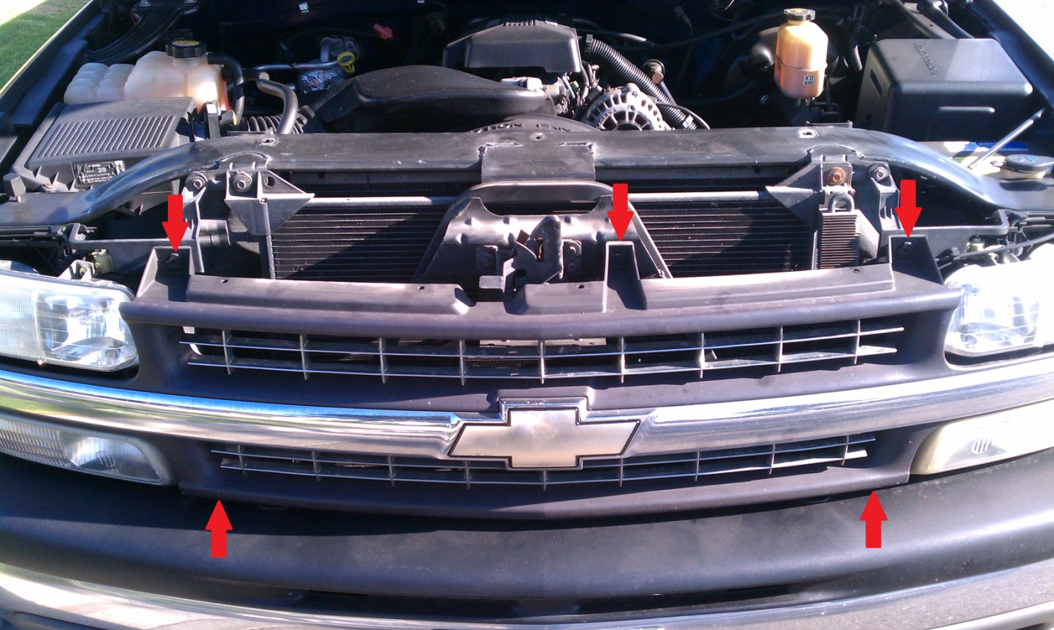

For the 03-07 classic style grille removal. With the core support cover off, you will be able to see where the metal grille clips attach to the head light bucket. The grille should be held in place by metal pressure clips. Carefully pull away so that you don’t damage anything.
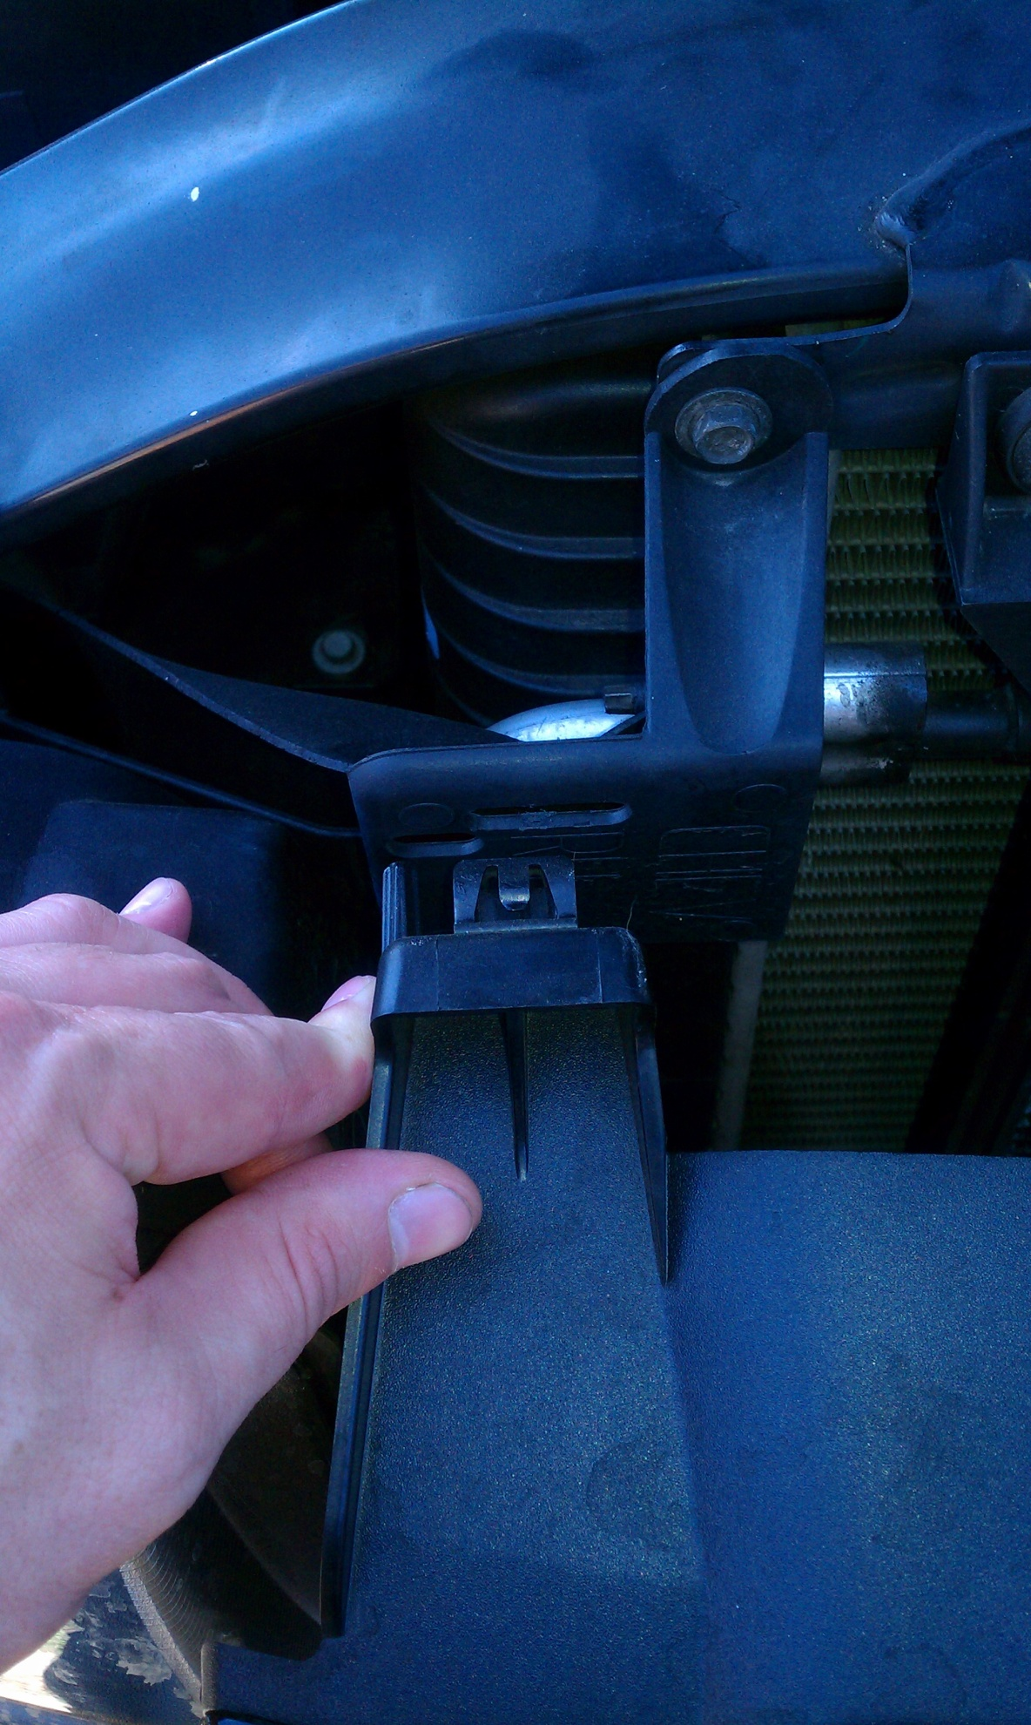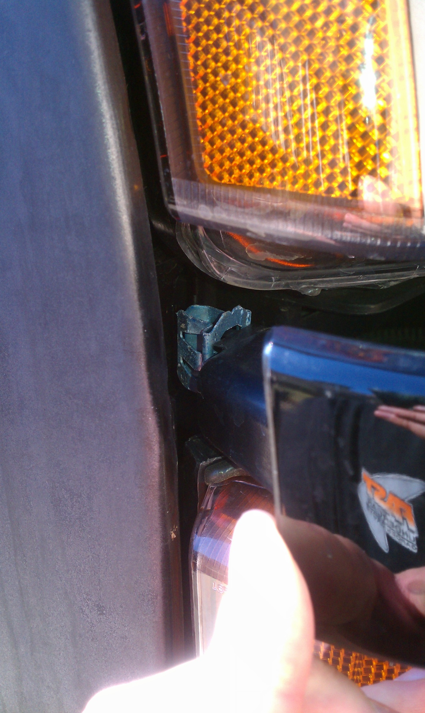
Once you remove the grille you will need to remove the factory external cooler with lower bracket. It is held in place by 4 screws. Pull the Lines from the cooler by removing the wire E-clip from the cooler fittings. If you have a sensor attached to the lower bracket, remove it from the lower bracket. You will re- attach it to the new bracket later.
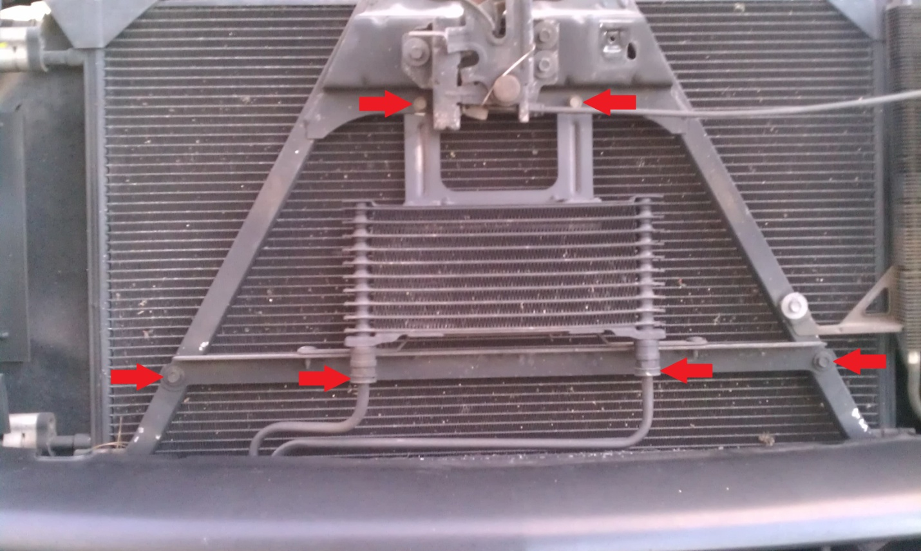
You will also need to remove the cooler lines from the plastic clip at the bottom of the radiator. You can remove the clip since the lines will no longer fit after the conversion is done.
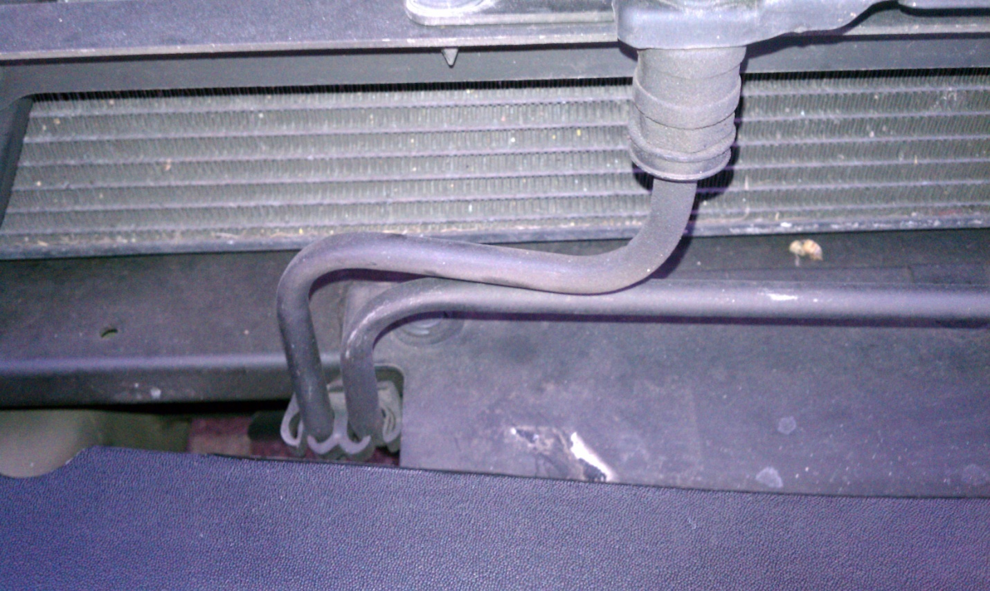

Save the top 2 bolts and clips from the cooler. You will need to re-use them with the new upper bracket from the cooler kit. With everything out of the way, you will want to install the 2 supplied cooler fittings from the cooler mounting kit into the new cooler. Then install the black U-clips onto the bracket with the flat side up as shown, the thread portion should be facing rear ward toward the radiator. The brackets will fit in the same fashion on the vehicle.
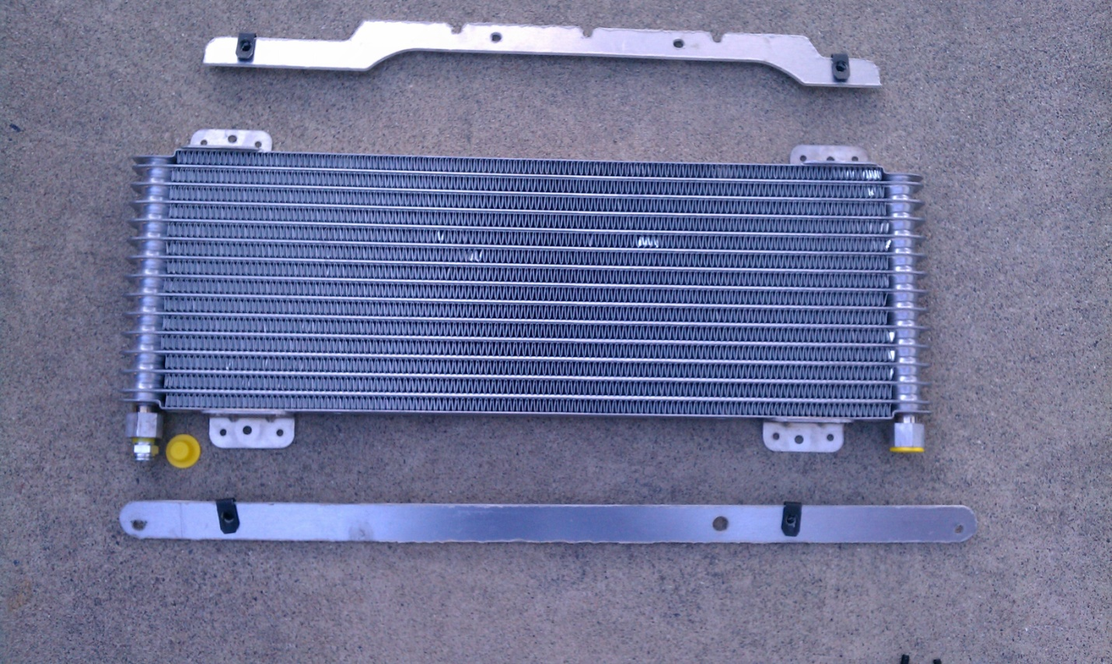
At this time you will also want to cut the short transmission line near the clip mounting area so that you can rotate it 180* You may also need to remove or modify the splash pan on the core support to accomidate the lines fitting the new cooler. ***BEFORE YOU CUT*** make sure the fitting will fit properly and that it won’t sit to high or low. You only get 1 shot to cut it. The tubing won’t seal in the bent area the tubing must be round for the compression ring to seal properly. Please view the following picture below before cutting the line. Use a tubing cutter and clean any metal from both half’s of the line before re-installing. Use the Brass compression fitting supplied with the cooler kit to join the 2 halfs back together as shown.
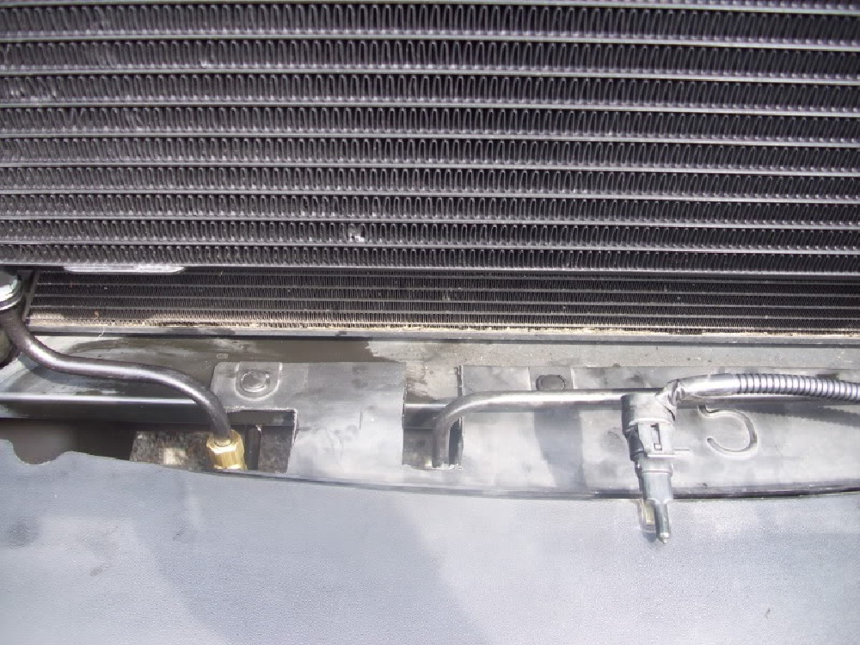If you have a factory temp ambient temp sensor on the 03-07 classic, it can be installed into the additional hole on the new lower bracket. Release the tabs and remove from the old bracket. Install on the new bracket from behind so that the Electrode is facing forward and that the Electrical plug is behind the cooler. Your completed installation should look similar.
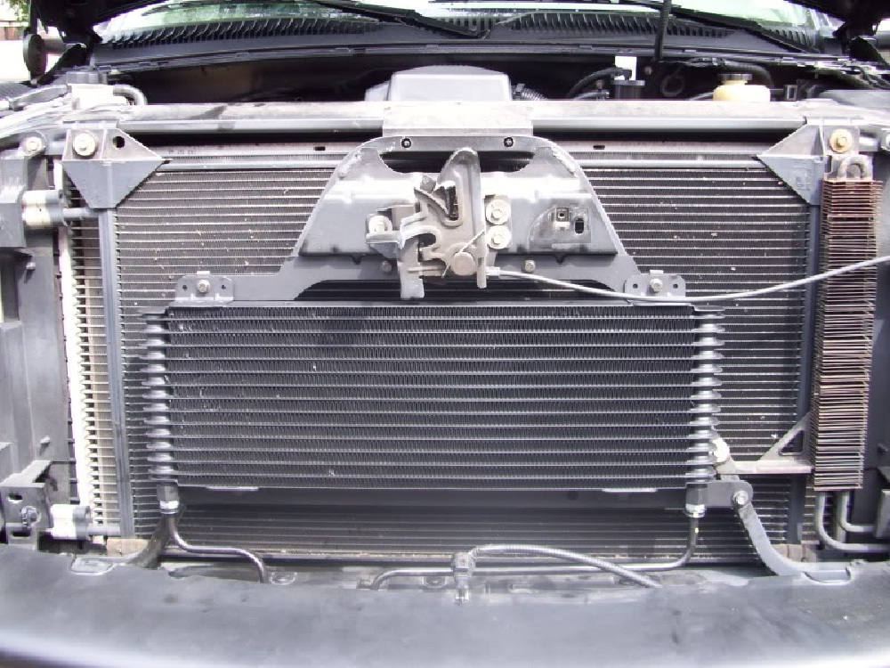
Note the difference in size between the OEM and the new cooler.
***The following picture is ONLY FOR COMPARISON***

